FCIA INDUSTRY CONFERENCE / TRADE SHOW 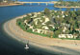
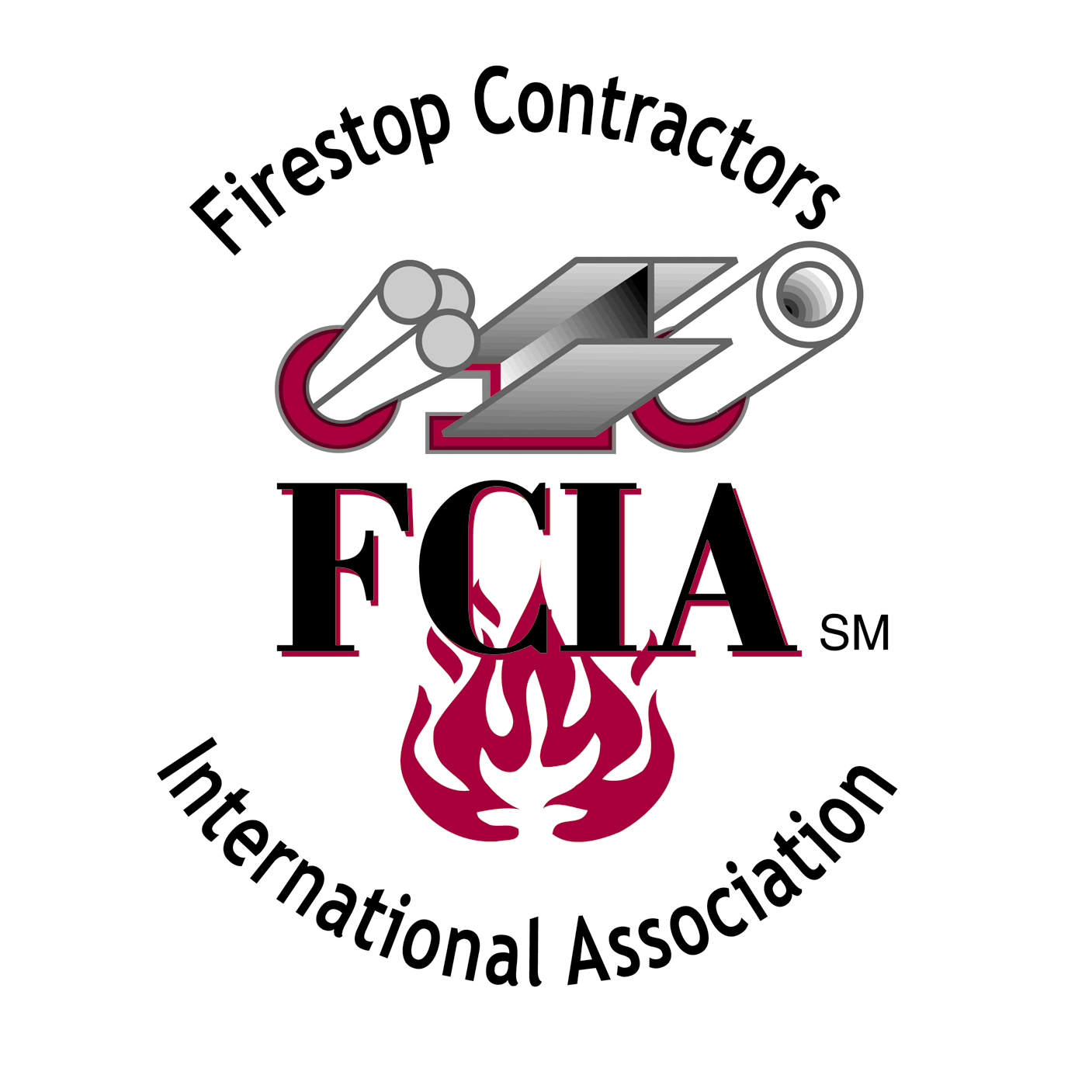
November 10 & 11, 2005 – Paradise Point Resort
Official FCIA Trade Show Tabletop Information

LOCATION: Paradise Point Resort, San Diego, CA

WHO’S ATTENDING FCIA Members, Invited Building Officials, Fire Marshals,
Architects and General Contractors

WHAT IS AVAILABLE “Tabletops” - 24” Deep x 6’ wide.
- All display materials must meet this size requirement.
- The Trade Show will be located in the Mission Bay Room, and
the foyer area of the conference.
- Signage must be no larger than 22”x28”.
- Banners in trade show area only, hung by Paradise Point Staff only.
- Only 18 Tabletops available. Tabletop Location Assignments to be
determined by the FCIA Program Committee by late October.

COST & GUIDELINES: * Booth Fee: $450 FCIA Member, $600 non member.
* Attendance Fees:
  - 1st person attending - $495 conference for Members; $595 Non Member.
  - 2nd person $395, members and non members.
All Trade Show Personnel must pay the conference attendee fee.

Tabletop Display includes draped table, electrical cord / socket, handling
of booth materials, storage of shipped materials. Setup is Wednesday,
after 5pm. Displays must be set by Thursday, November 9, 2005, at 7am.

PRELIMINARY DISPLAY TIMES
Wednesday, Nov. 9 After 5:00pm Tabletop Set Up
Thursday, Nov. 10 Tabletop Set Up & Display
7:30 am – 8:30 am Conference Registration / Continental Breakfast / Trade Show Area
8:30 am – 3:30 pm General Session & Featured Speakers: Breaks in Trade Show Area
3:30 pm – 5:00 pm FCIA Trade Show
Friday, Nov. 11 Tabletop Display and Takedown
7:30 am - 8:00 am Continental Breakfast - Trade Show Area
8:00 am –12:10 pm Seminars – Breaks in Trade Show Area
3:00 pm Tabletops out of Trade Show area

SIGN UP USING FCIA’s REGISTRATION FORM, AVAILABLE ONLINE AT http://www.fcia.org.
SEE FCIA SPONSORSHIP FORM FOR ADDITIONAL PROMOTIONAL OPPORTUNITIES

