FCIA INDUSTRY CONFERENCE / TRADE SHOW 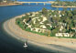
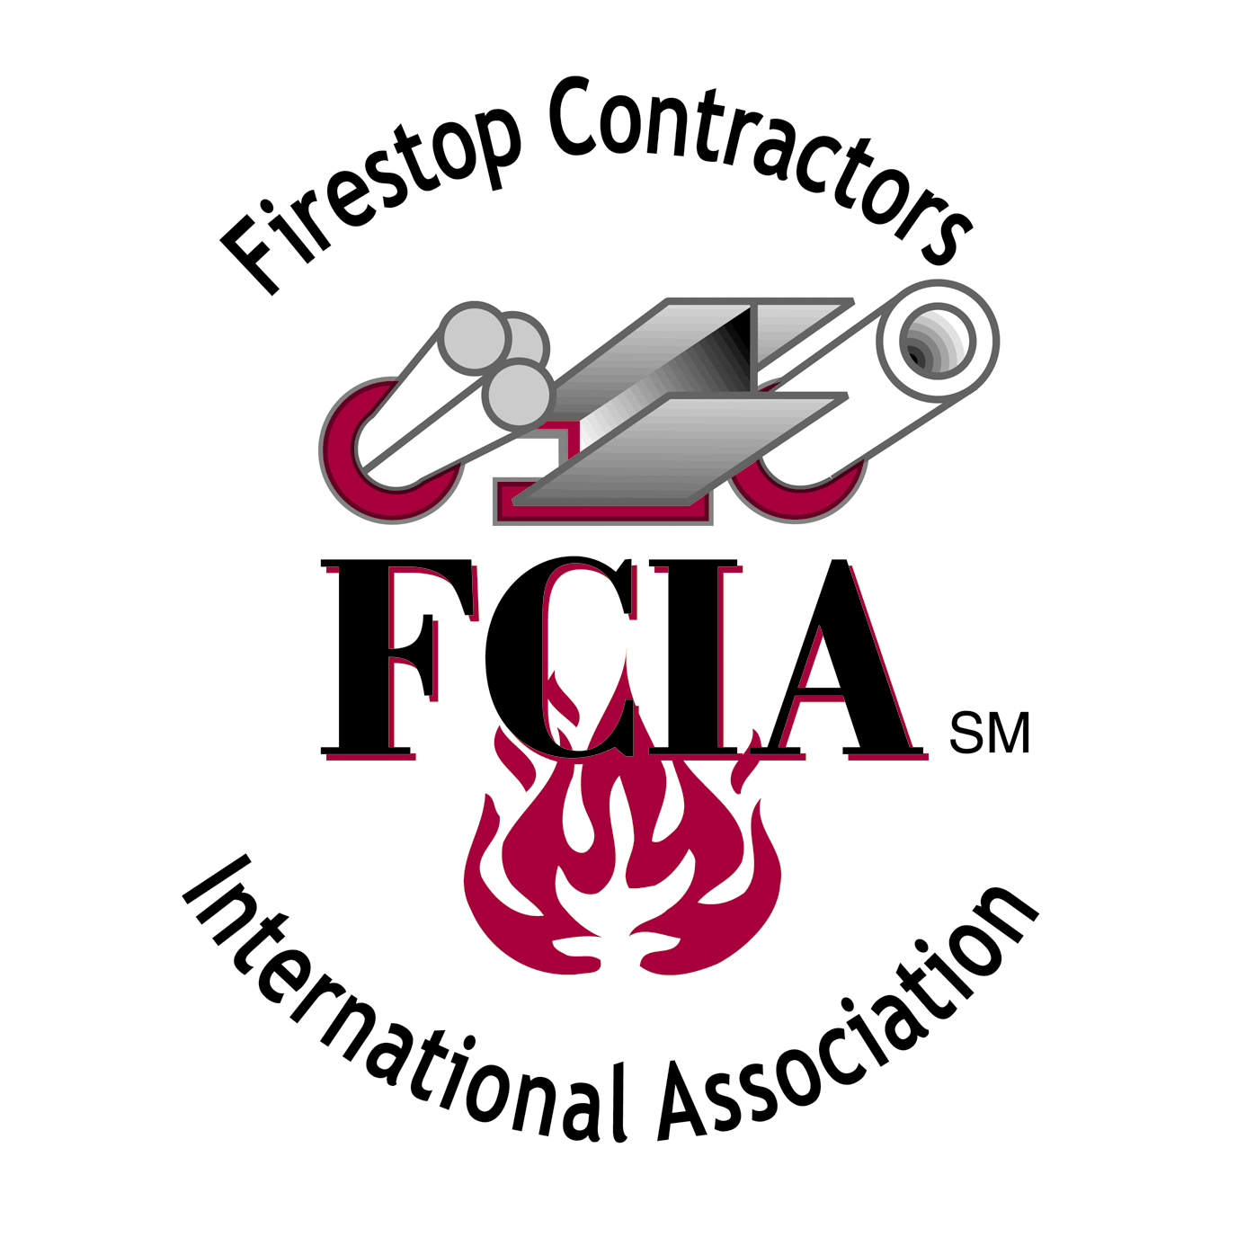
November 10 & 11, 2005 – Paradise Point Resort
Official FCIA Sponsorship Information

LOCATION: Paradise Point Resort, San Diego, CA

WHO’S ATTENDING FCIA Members, Invited Building Officials, Fire Marshals,
Architects and General Contractors

WHAT’S AVAILABLE: Breaks – $500 – Exposure – ¼ Page Advertisement in FCIA Agenda
- Wednesday AM
- Wednesday PM
- Thursday AM
- Thursday PM
- Friday AM

Lunches - $1000 – Exposure – ½ Page Advertisement in FCIA Agenda,
2 minute presentation at luncheon, priority placement by committee
at Trade Show.
- Wednesday
- Thursday

Spouse Tours - $500 – ¼ Page Advertisement in FCIA Agenda
- Transportation
- Breakfast
- Lunch

BENEFITS TO SPONSORSHIP:

- Exposure at the FCIA Conference
- Exposure in FCIA Conference Materials
- Exposure in FCIA Enews
- Exposure on FCIA Website
- 2 minutes to present your firm at lunch
- Priority placement by committee at Trade Show

SIGN UP USING FCIA’s REGISTRATION FORM, AVAILABLE ONLINE AT http://www.fcia.org.
SEE FCIA SPONSORSHIP FORM FOR ADDITIONAL PROMOTIONAL OPPORTUNITIES

