FCIA INDUSTRY CONFERENCE / TRADE SHOW

November 11, 2005 – Paradise Point Resort

Official FCIA Ray Usher Memorial Golf Tournament

LOCATION: Steele Canyon Golf Club, San Diego, CA
A Gary Player Designed Golf Course

WHO’S ATTENDING FCIA Members & Guests

WHAT’S THIS ABOUT FCIA Past President, Ray Usher, was taken by Cancer May 30, 2005.
Ray’s passion for life, family, the USA and business was unequalled. As a tribute
to Ray, FCIA’s Golf Tournament has been named in his honor. FCIA’s Board
directed that proceeds are to be used for Fire Protection Education.

Join us for some great golf, fun, fellowship, and competition to benefit
the education of influences in the fire protection industry about Firestopping and
Effective Compartmentation’s importance to fire and life safety.

PRIZES: Prizes awarded for the following honors
- Long Drive, Long Putt, Tournament Champion, “Unique Play”

COST TO PLAY: $160, includes golf, cart, range balls, lunch, transportation to / from the course.
Guests of FCIA Members are welcome to play!

Rental Clubs - $50 / set, Taylor Made clubs.

SPONSORSHIPS: Golf Holes - $200
Bus - $500 Prizes - Golf Balls, Tees, other giveaways welcome.
FCIA to place giveaways on carts. All FCIA Attendees are eligible to sponsor!

SIGN UP USING FCIA’s REGISTRATION FORM, AVAILABLE ONLINE AT http://www.fcia.org.
SEE FCIA SPONSORSHIP FORM FOR ADDITIONAL PROMOTIONAL OPPORTUNITIES

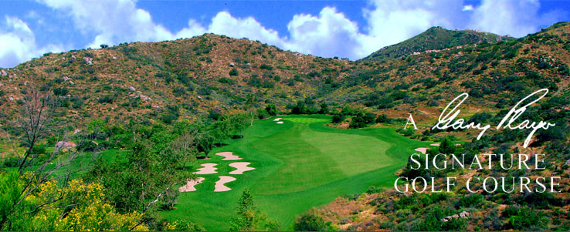
Ray Usher- 1953-2005 Steele Canyon Golf Course

