FCIA INDUSTRY CONFERENCE / TRADE SHOW 
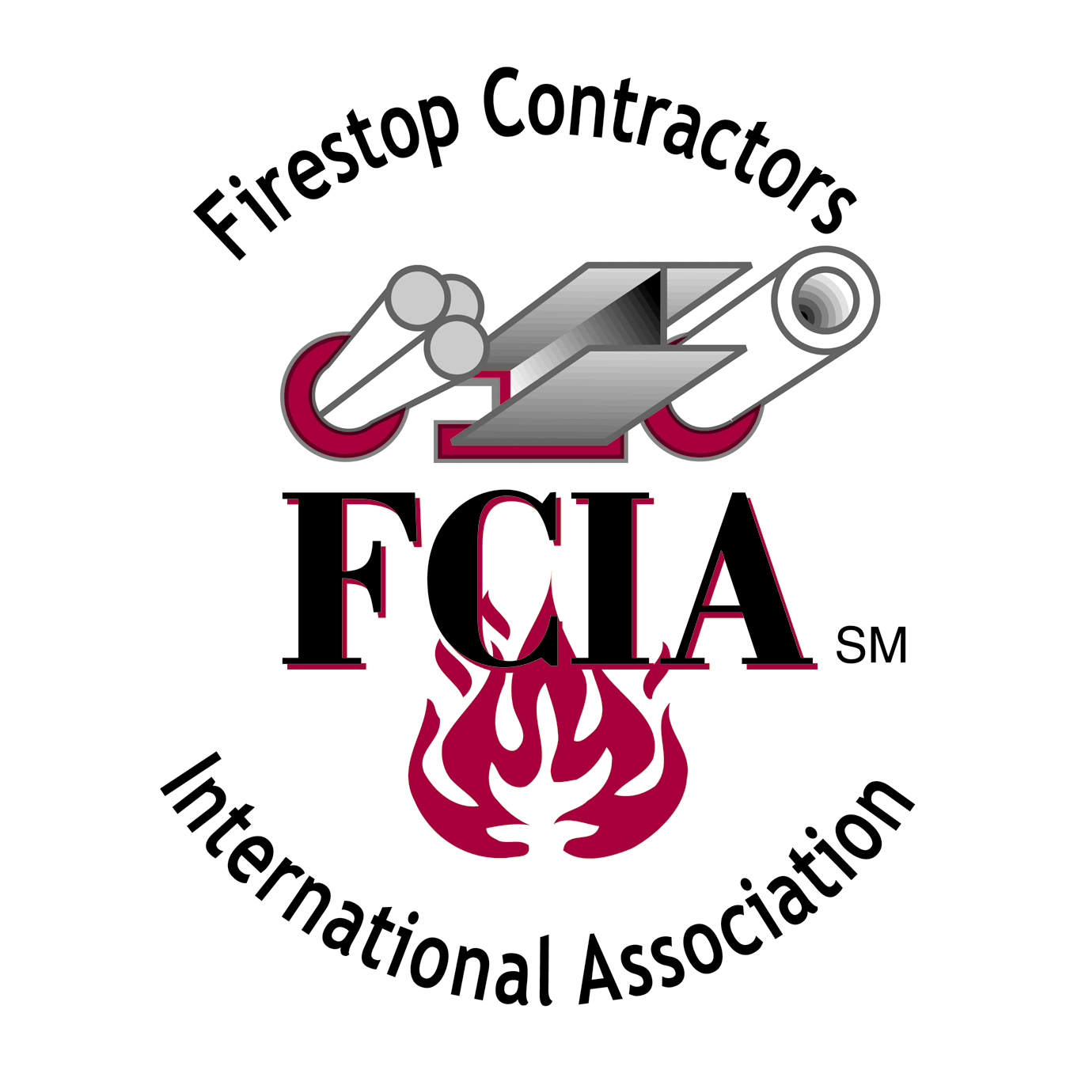
November 10, 2005 – Paradise Point Resort
Official Architect & Engineer Invitation

LOCATION: Paradise Point Resort, San Diego, CA
WHAT’s HAPPENING: FCIA’s Firestop Industry Conference Effective Compartmentation Seminar
9:15 am – 5 pm ~ November 10, 2005 – Includes Lunch & Trade Show!

9:15 am – 10:30 am Firestopping and the new CSI MasterFormat Specifications
Dennis Hall, Hall Architects, aka “Southern Fried Architect”
Dennis brings updates on CSI’s New MasterFormat Specification sections
for Firestopping and adds some good Southern Humor while he’s at it.

10:30 am – 12:00 pm FCIA Accreditation Update
FCIA Project Profiles – Interesting Problems & Solutions
Rob Hlady, Affinity Architecture
Tony Gamble, APEX Firestopping
Woody Smith, Chesapeake Firestop

12:30 am - 1:30 pm Luncheon Speaker –State of California, Office of Statewide
Health, Planning and Development Office

1:30 pm – 3:30 pm Effective Compartmentation Roundtable
Together, We Promote Fire and Life Safety
Join the complete Effective Compartmentation Industry in one place.
Door Hardware Institute, Fire Damper Industry, FCIA, International
Masonry Institute, FireGlass Industry, Gypsum Industry.

3:30 pm – 5:00 pm FCIA Firestop Industry & Effective Compartmentation Trade Show
Open to all FCIA Conference Attendees, Architects, Engineers, Code
Officials and Fire Marshals (registration required, limited
availability)

COST TO ATTEND: $65 AIA or CSI Members, Fire Marshals, Code Officials
AIA or CSI Non Members, $175

WHY ATTEND: Earn 6 HSW CEU Credits!! Learn about Firestopping
Understand Firestopping & Effective Compartmentation
Benefits to Fire and Life Safety plus operations continuity.

For more information, FAXBACK the registration form with charge card info, or mail a check!
Registrations are limited, so don’t delay. Contact 630-690-0682 or visit http://www.fcia.org for info.
