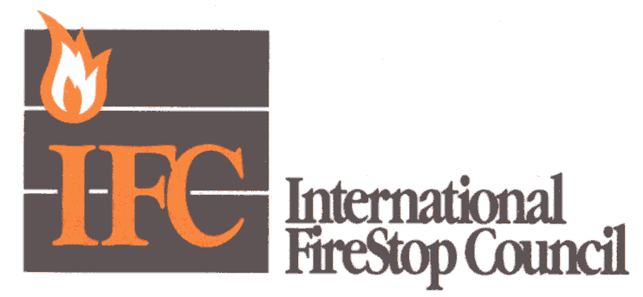Aug. 25, 2005

Dear Editor:

This letter is in response to an advertisement that appeared in the July 2005 issue of National Bulletin regarding the “potential vagaries” associated with the selection of the appropriate firestop system. BIBBY-STE-CROIX’s featured dozens of assorted, random donuts in an attempt to draw the analogy that the selection of a firestop is a random and confusing process. (I assume that the donuts represent firestop collars, ironically one of the simplest firestop systems to select and install.)

This misleading ad suggests that cast iron pipe does not require a firestop device. While technically accurate, the ad communicates nothing about the fact that cast iron pipe require a tested firestop system that will likely not include a device or collar. This may end up including a predetermined amount of fire-rated sealant and mineral wool. But installing nothing, which is what this advertisement advocates, is a direct violation of the current NBC. In fact, by following this ill-informed directive, the life and safety of building occupant is compromised.

On behalf of the International Firestop Council (IFC), I find this intentional misdirection is reprehensible. Contrary to the ad’s claim that the process for selecting firestopping products is one of “utter confusion,” the firestopping industry, comprised of many well-respected manufacturers, has made great strides in the last decade to bring a high degree of organization and regimen to the selection process.

I encourage your readers to visit IFC’s Web site, www.firestop.org, detailed information and direct links to the largest suppliers in the industry who have excellent tools available to afford accuracy and simplicity in the selection process. The companies involved in the IFC – unlike others who hide behind non-descript banners – take direct responsibility for helping the consumer make informed selections.

Sincerely,
Steven M. Tyler
President, International Firestop Council

