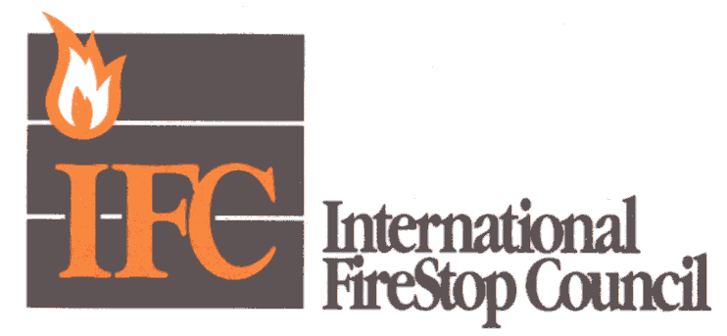

August 25, 2005

Dear Editor:

This letter is in response to an advertisement that appeared in the July 2005 issue of National Bulletin regarding aging of firestop devices. The ad from the Cast Iron Soil Pipe Division of the Canadian Foundry Association featured a stale donut and inquired about the “freshness” of firestop devices. It also referenced a study conducted by Tollefson Engineering Enterprises at the University of Calgary that had reportedly “found” the lifespan of these products is between five and 15 years. Additionally, it stated that no firestop device manufacturer is willing to provide data proving the useful lifespan of their products.

I am the chair of ASTM Task Group E06.21.12, which deals with firestop age testing, and I have published a considerable amount of research results on firestop aging over the last two decades. I would therefore like to address some of the issues raised by this misleading ad.

In my detailed examination of the Tollefson Engineering study, supported by additional review by a PhD physicist, we came to the following conclusions:
- The study was not conducted with any known testing standard for aging materials.
- The study’s methodology did not follow proper scientific principles in testing, therefore the results can not be interpreted to be meaningful.
- As a sample, some of the flaws of the study were that accelerated “aging” was accomplished simply by exposing materials to light bulbs
- The samples that were used were so small, it was practically impossible to measure changes in the material.
- Limited time studies were conducted and then it was inappropriately attempted to calculate expected aging without running the experiments at three or more temperatures (which would be needed to extrapolate accelerated aging to actual aging).
- The materials were tested at temperatures above the intumescent activation temperature. (Tests were conducted above 100˚ C, which is the activation temperature of the material.)

The materials that Tollefson tested were materials that had passed the UL exposure studies for intumescent materials, and were listed by UL for use in fire protection devices. These materials had also undergone successful aging studies in countries such as Germany using the DIN standards for this testing.

Additionally, the material is used in the nuclear industry – which requires that the manufacturers prove that the material will work for at least 40 years. The manufacturer supplied information and testing showing that the material would last longer than 100 years and still maintain its required level of intumescence. The manufacturer also pulled samples of the material – installed more than 20 years before – from both nuclear and commercial facilities, tested the material, and determined that it met the original specifications for all of its properties.

When all is said and done, this material has passed far more testing than almost any other material used in the construction of a building.

Another point of the ad that is also misleading: “To this day, no firestop device manufacturer is willing to provide data proving the useful lifespan of their products!” The manufacturer of the product tested by Tollefson supplied volumes of information on its testing procedures to the organizations sponsoring the Tollefson study; posted that data on its Web site; published articles on the subject; and presented the data and analysis at national fire education seminars. Given that level of proactive outreach, the statement that “no firestop manufacturer is willing to provide data proving the useful lifespan of their products” is simply not the truth.
Predicting the lifespan of products is a difficult task. Aging is not just a simple matter of testing to heat exposure, as many other conditions can affect the performance of materials, including moisture, humidity, sunlight, CO2/SO2, oils, fumes, etc. I invite your readers to go to the International Firestop Council’s Web site (www.firestop.org) to review all of the accurate information that is available on firestop materials and devices, and to disregard misleading advertisements that seek to sell one type of product by falsely disparaging an entire industry.

Richard L. Licht
Code Action Committee Chair, International Firestop Council
RRL Consulting Solutions

